Ex.No. 11: Implementation of IoT-based Smart Agriculture using MATLAB
AIM:
To design and simulate an IoT-based smart agriculture system using MATLAB by monitoring soil moisture levels, controlling water pump status (ON/OFF), and evaluating irrigation efficiency for optimized water resource management.
Objective:
- To monitor the Soil Moisture (%) level in agricultural fields using IoT-based sensing simulation in MATLAB.
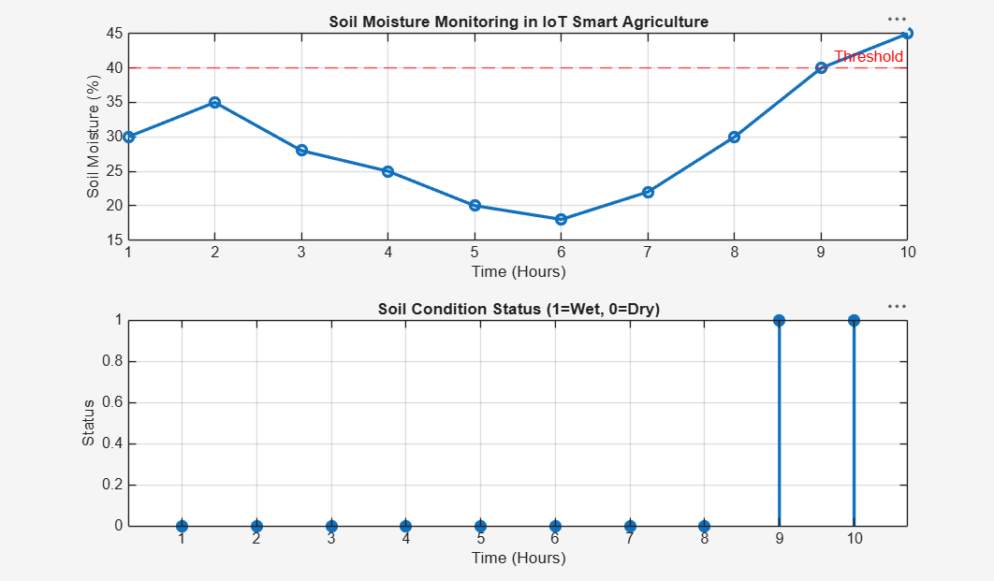
- To control and display the Water Pump Status (ON/OFF) based on threshold soil moisture conditions.
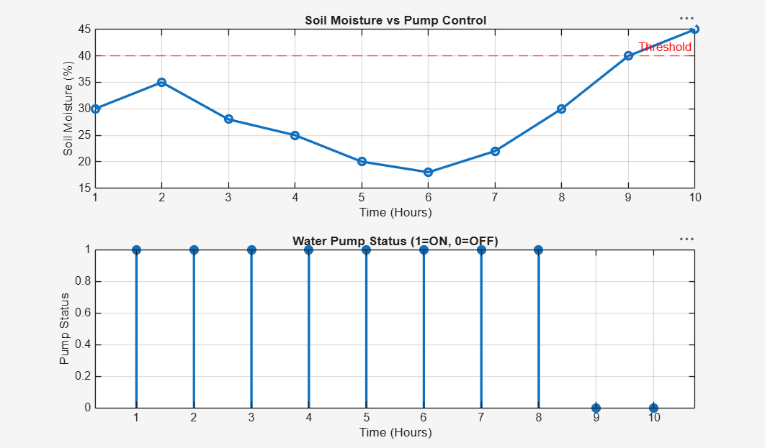
- To evaluate the Irrigation Efficiency (%) by analyzing water usage effectiveness and moisture maintenance level.
